Institute of computer technology

B.Tech-CSE(BDA)

Name:- Shaikh Anik

Sem:-3

Enrollment no.:-23162121021

Batch:-31

Sub:-DBMS

Date:-14/8/24

Practical 5

Q:- 1) How many employees are there in each department?

2) Find out total number of job role assigned in each department.

3) Find out employee’s names and salary whose having salary more than 2000.

(Duplication in employee name should be removed)

4) Find out number of employees hired after 03rd April 1991.

5) lists the number of employees in each job role, sorted high to low.

6) lists the number of employees in each department. Only include department with

more than 3 employees in each.

7) Display the total amount of the salary on each department.

8) Count total number of employees assigned in each department whose name end

with “n”.

9) Find out total number of employees having "a" as a character in their name in

each department.

10) Find out total number of employees having salary more than average salary of

all the employee in each department.

11)Display total number of employees in each department whose department

having more than 2 employees also display department id in descending order.

12) Display department wise average salary of employee.

13)Display department id of the employee along with salary whose salary is

maximum in respective department.

14)Display department id of the employee along with salary whose salary is

minimum in respective department.

A=> Query:- use bda_23162121021;

create table employees (emp_id int, emp_name varchar(20), job_name varchar(20), hire_date date, salary decimal(10, 2), dep_id int);

show variables like 'secure_file_priv';

show variables like 'local_infile';

show global variables like 'local_infile';

show session variables like 'local_infile';

load data infile 'd:\\d_drive\\practicals\\sem 3\\[2024] dbms - 2023 batch\\emp_mstr.csv'

into table employees

fields terminated by ','

enclosed by '"'

lines terminated by '\n'

ignore 1 rows;

1)select dep_id, count(emp_id) as employee_count from employees group by dep_id;

2)select dep_id, count(distinct job_name) as job_role_count from employees group by dep_id;

3)select distinct emp_name, salary from employees where salary > 2000;

4)select count(emp_id) as employee_count from employees where hire_date > '1991-04-03';

5)select job_name, count(emp_id) as employee_count from employees group by job_name order by employee_count desc;

6)select dep_id, count(emp_id) as employee_count from employees group by dep_id having count(emp_id) > 3;

7)select dep_id, sum(salary) as total_salary from employees group by dep_id;

8)select dep_id, count(emp_id) as employee_count from employees where emp_name like '%n' group by dep_id;

9)select dep_id, count(emp_id) as employee_count from employees where emp_name like '%a%' group by dep_id;

10)select dep_id, count(emp_id) as employee_count from employees e1 where salary > (select avg(salary) from employees e2 where e2.dep_id = e1.dep_id) group by dep_id;

11)select dep_id, count(emp_id) as employee_count from employees group by dep_id having count(emp_id) > 2 order by dep_id desc;

12)select dep_id, avg(salary) as average_salary from employees group by dep_id;

13)select dep_id, max(salary) as max_salary from employees group by dep_id;

14)select dep_id, min(salary) as min_salary from employees group by dep_id;

Screenshot:-

1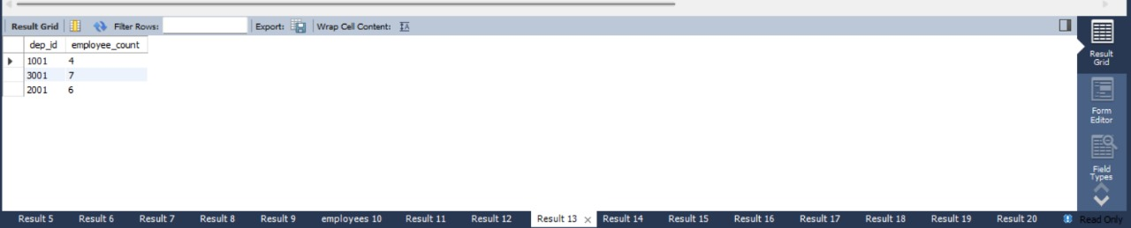

2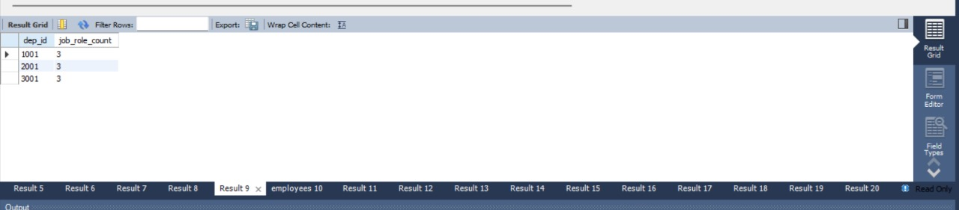

3

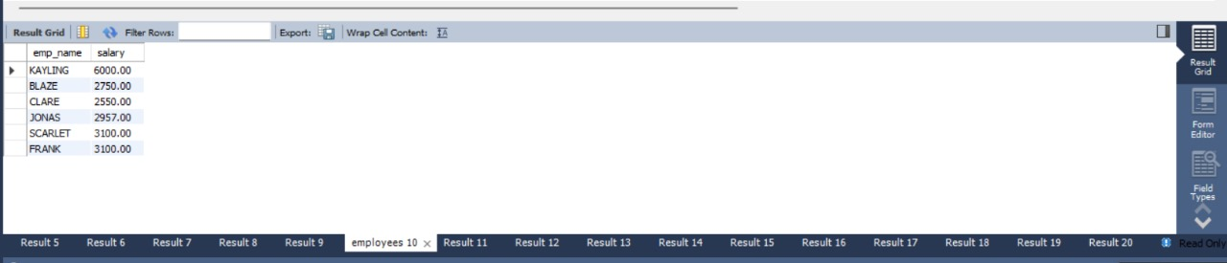

4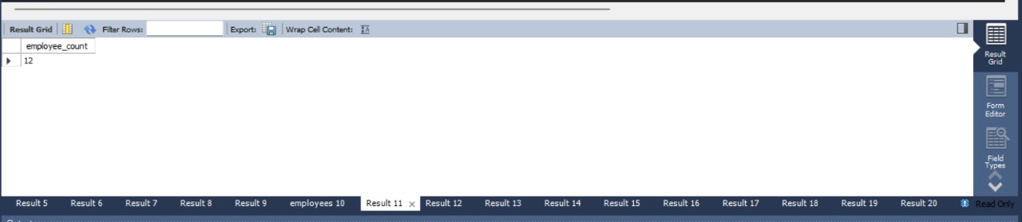

5 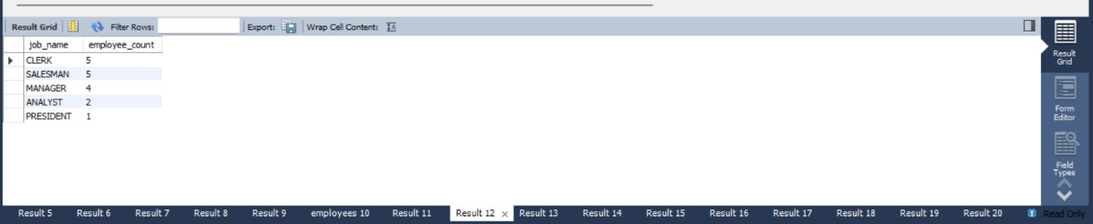

6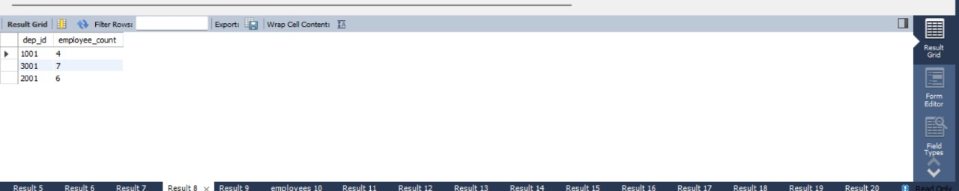

7 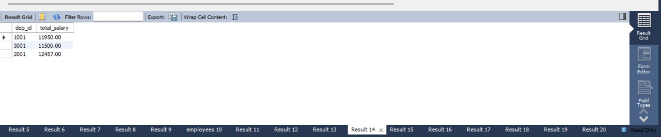

8 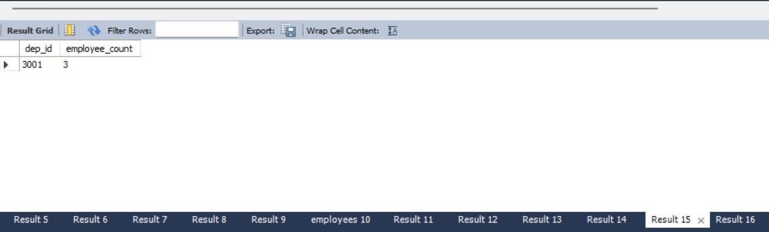

9 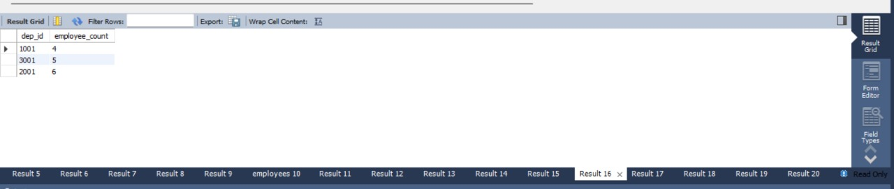

10 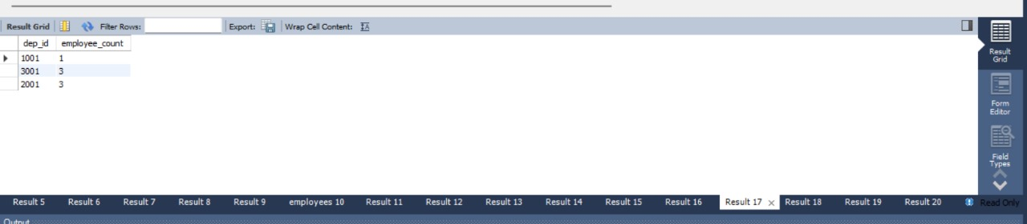

11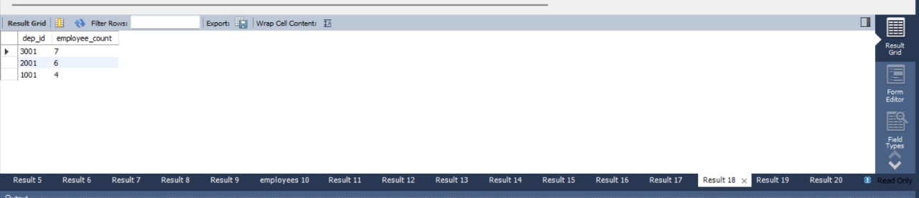

12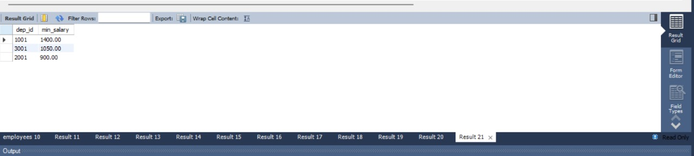

13 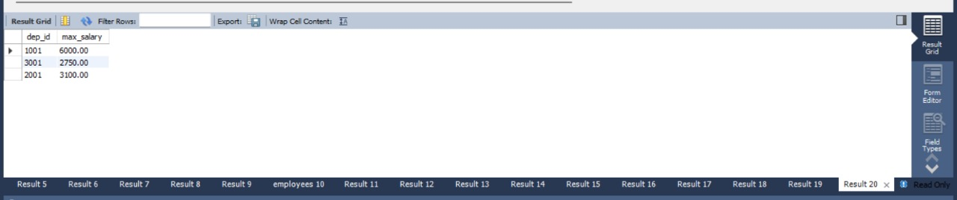

14 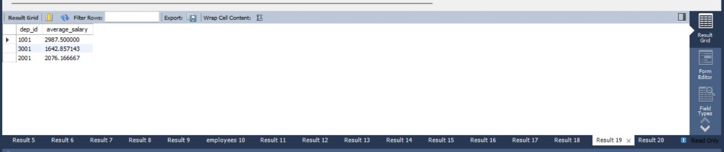

Action logs:-